Marine Protected Areas in Murlough SAC MarPAMM Region

Introduction
Marine and coastal environments are important ecosystems for the provisions of ecosystem services to sustain societal and ecological livelihoods, through the goods and services it provides. The marine environment of Northern Ireland are home to some of the most internationally important and biologically diverse habitats and species. It is important that these environments are managed in an appropriate way for the maintenance of the social, environmental and economic well-being of our society. As of 2014, 14% of our waters are afforded some protection based on a network of protected areas.
There are several types of Marine Protected Areas (MPA) in the Northern Ireland, which in combination are intended to form an 'ecologically coherent and well-managed network' as a contribution to the effective conservation and sustainable use of the Northern Ireland’s marine environment. The term “MPA” is
“Any area of intertidal or subtidal terrain, together with its overlying water and associated flora, fauna, historical and cultural features, which has been reserved by law or other effective means to protect part or all of the enclosed environment”
MPAs designate a wide range of marine areas which "have some level of restriction of activity to protect living, non-living, cultural and/or historic resources”. They are designated primarily to
“Help conserve or recover nationally significant or representative examples of marine biodiversity, including threatened or declining species and habitats of European and national importance”.
MPAs are one of the tools that can help to protect the marine environment, enabling its sustainable use, ensuring it remains healthy and contributes to our society for generations to come. In Northern Ireland various forms of MPA have been designated under different legislations at both national and international levels due to international agreements and national legal obligations.
Northern Ireland Marine Protected Area Network

The Northern Ireland Executive through the Department of Agriculture, Environment and Rural Affairs (DAERA), is committed to the continued development and enhancement of a well-managed and ecological network of MPAs from a devolved perspective and through the UK’s contribution to the OSPAR network

International Designations

Special Protection Areas (SPA) are sites that have been designated for seabirds of European importance and are classified under the Wild Birds Directive. Species listed under Annex I of this Directive, including Razorbill, Guillemot and Kittiwake are protected, along with their essential habitats. The Directive requires measures to be taken to maintain populations of all naturally occurring birds.
Special Areas of Conservation (SAC) are sites designated under the Habitats Directive for habitats of European importance. SACs are designated for habitats and species listed under Annex I and II of the EC Habitats Directive, such as reefs and sandbanks. The Habitats Directive requires Member States to take measures that contribute to the conservation of biodiversity by maintaining or restoring certain habitats and species at a favourable conservation status. The Habitats Directive was transposed by The Conservation (Natural Habitats, etc) Regulations (Northern Ireland) 1995 and is required to identify and protect a series of Special Areas of Conservation (SACs).
Collectively SPAs and SACs are known as the Natura 2000 network which is a European network of nature conservation protected areas. This network is the cornerstone of Europe's nature conservation policy, protecting important habitats and also laying out a strict system of species protection in order to protect biodiversity.
Where a SPA or a SAC incorporates a subtidal and/or an intertidal area, they are also referred to as ‘European Marine Sites’ (EMS). EMSs are areas at sea that are designated to protect wildlife and habitats that are important at a European level. They are created under EU Legislation. There are two types of EMS: Special Protection Areas (SPAs) which protect birds and their essential habitats and Special Areas of Conservation (SACs) which protect other wildlife and important habitats.
The UK is signed up to is the “Convention on Wetlands of International Importance”, the Ramsar Convention 1971. The convention solely focuses on the sustainable use of wetlands, to ensure their effective management. The convention has a commitment to international coordination on transboundary and shared wetland and species.
National Sites
Across the UK, each devolved administration has the power to create Marine Protected Areas to conserve nationally important wildlife and habitats. These national sites have different names in the devolved nations of the UK. The Marine Act (Northern Ireland) 2013, establishes a strategic system of marine planning within the inshore region (out to 12 nautical miles) and helps to streamline the process of marine licensing. The Act enables the delivery of an “ecologically coherent network of Marine Protected Areas”, through giving DAERA the power, with the agreement of the Secretary of State, to designate MPAs, called Marine Conservation Zones (MCZ).
Areas of Special Scientific Interest (ASSIs) are designated under The Environment (Northern Ireland) Order 2002. It contains powers for the protection of nationally important flora and fauna within Northern Ireland. Schedules of listed nationally important habitats and species include reference to coastal and marine features, including mudflats and common seals.
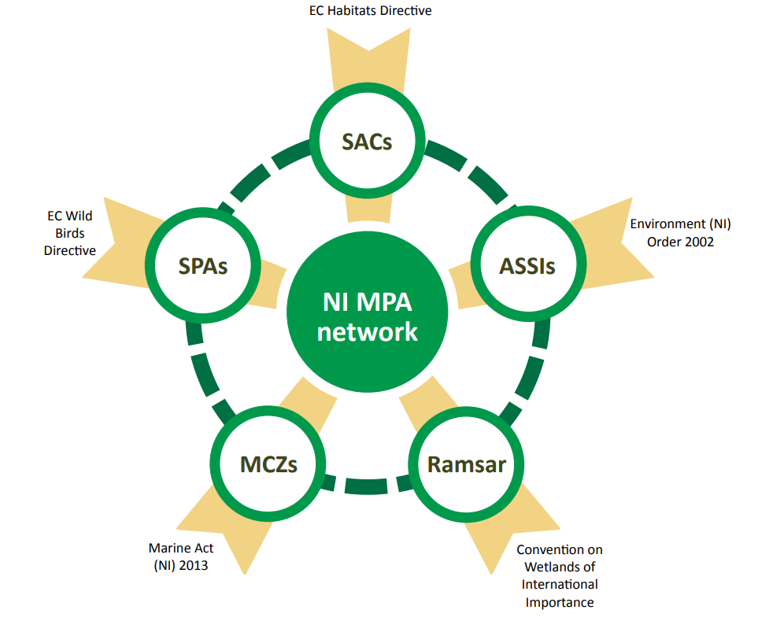
Figure 1: Ecologically coherent network of Northern Ireland’s Marine Protected Areas
Source: DAERA, 2014
Other Notable International Obligations
- The OSPAR Convention to develop an ecologically coherent network of well-managed MPAs by 2016;
- The World Summit for Sustainable Development (WSSD) in 2002 to establish a representative network of MPAs;
- The Water Framework Directive, transposed into the Water Environment (Water Framework Directive) Regulations (Northern Ireland) 2003; and
  - Sets out that Member States must aim to achieve good chemical and ecological status in identified water bodies by 2015. This includes transitional (estuarine) and coastal waters out to one nautical mile
- The Marine Strategy Framework Directive (2008) requires that Member States prepare national strategies to manage the seas to achieve or maintain Good Environmental Status.
  - The UK Marine Strategy provides the framework for delivering marine policy at the UK level and sets out how we will achieve the vision of clean, healthy, safe, productive and biologically diverse oceans and seas.

Marine Protected Areas Murlough SAC Region
Murlough SAC Northern Ireland
Murlough SAC (11902.03 ha) adjoins Dundrum Bay and includes the shallow waters of the Bay itself of importance as the largest area of shallow sub-littoral sandbanks in Northern Ireland. The inter-tidal sands and muds are also extensive, the beach area at Ballykinler is important as a haul-out for Common Seal. The terrestrial element comprises the major dune systems of Murlough and Ballykinler, together with the relatively intact low dunes and ridges within Royal County Down golf club.
The seaward boundary includes Outer Dundrum Bay, its line being determined by the main area of sublittoral sandbanks. The landward boundary includes all undeveloped beach area between Newcastle harbour and the western end of Tyrella Beach (this being the presumed active coastal unit associated with the selected dune complexes), the main dune system at Murlough, including the Royal County Down golf course, and at Ballykinler. The boundary in Inner Dundrum Bay includes all inter-tidal habitat, together with all substantive units of adjoining semi-natural habitat.
This area has been designated as a Special Area of Conservation (SAC) because it contains habitat types and/or species which are rare or threatened within a European context. The Atlantic salt meadows habitat, encompasses saltmarsh vegetation containing perennial flowering plants that are regularly inundated by the sea. The species found in these saltmarshes vary according to the duration and frequency of flooding with seawater, geographical location and grazing intensity. Salt-tolerant species, such as common saltmarsh-grass (Puccinellia maritima), sea aster (Aster tripolium) and sea arrowgrass (Triglochin maritima), are particularly characteristic of the habitat.
The SAC contains a significant presence of embryonic shifting dunes, which are considered to be rare as its total extent in the United Kingdom is estimated to be less than 1000 hectares. These are low dunes that develop along the upper shore above the high tide line. Only a few plant species are able to survive in these conditions, such as sand couch (Elymus farctus), sea sandwort (Honckenya peploides) and sea rocket (Cakile maritima).
Shifting dunes along the shoreline with white dunes (Ammophila arenaria). These are actively-building or growing dunes, found in areas receiving large quantities of blown sand. Continual burying by sand restricts the number of plants that can survive but provides ideal conditions for the growth of sand binding marram Ammophila arenaria.
This area is considered to support a significant presence Mudflats and sandflats not covered by seawater at low tide. Intertidal mudflats and sandflats are mud and sand sediments on the shore that are exposed at low tide but submerged at high tide. Many sites are important feeding areas for waders and wildfowl.
The areas has a significant presence of Sandbanks which are slightly covered by sea water all the time. Subtidal sandbanks are sandbanks that are permanently covered by sea water to depths of up to 20 metres below low water. These sandbanks can include muddy sands, clean sands, gravelly sands, eelgrass (Zostera mari).
The Common Seal (Phoca vitulina) is in a significant presence within the SPA. About 50% of the European Union population of common seals breed in the UK. Common seals range around the shore of the UK and are the characteristic seal of sandflats and estuaries, but are also found on rocky shores in Scotland.
The SAC contains a significant presence of Marsh fritillary butterfly. The marsh fritillary butterfly frequents damp meadows and, more rarely, chalk grassland, where its larvae feed on devil’s-bit scabious Succisa pratensis. It has declined and is now extinct from the eastern half of its former range in the UK (except where it has been reintroduced) and has shown a similar decline throughout Europe. The UK, Ireland and the Iberian Peninsula are now its most important strongholds.
Atlantic salt meadows (Glauco-Puccinellietalia maritimae) | SAC
Embryonic shifting dunes | SAC
Mudflats and sandflats not covered by seawater at low tide | SAC
Common Seal- (Phoca vitulina) | SAC
Marsh Fritillary (Euphydryas aurinia) | SAC
Sandbanks which are slightly covered by sea water all the time | SAC
Management considerations including, Main Threats, Pressures, Activities with impacts on the site or site features within the SPA Conservation Objectives Report are available on Page 10 of the Murlough Conservation Objectives SAC Report.
Murlough ASSI
The area is of special scientific interest because of the coastal flora, fauna and physiography. The Dundrum complex consists of the beaches and dunes at Ballykinler and Murlough, in addition to Inner Dundrum Bay and Newcastle beach. Physiographical interest lies in the sediment record associated with a prograding foreland and depositional sink, which dates back to the late Pleistocene and is of international importance. Studies of the Murlough system have been used to develop the chronology of Holocene sea-level changes in the north-east of Ireland. Modern dune deposits include the best examples of transgressive sheet and parabolic dunes in Northern Ireland, together with exceptional ridge and runnel beach forms.
Both Ballykinler and Murlough have a low angle, dissipative, wide sand beach. Sediments are of glacial origin with little or no modern sources, and the system is therefore sedimentalogically closed. The Murlough foreshore is noted for the well-developed ridge and runnel beach system, with up to five ridges exposed by extreme low spring tides. This is exceptional by Irish standards. An extensive ebb-tide delta occurs at the mouth of the channel from the Inner Bay at Dundrum, on which swash bars periodically form. Limited modern development of embryo dunes continues by localised reworking of sediments from these migrating onshore, particularly on the Ballykinler side where dune development continues at the south-western tip of this system and along the eastern shoreline of the Outer Bay. At least three dune ridges have formed around the dune edge on the ebb tide delta in recent years.
The coastal edge of the Murlough system is characterised by an irregular series of low modern dunes and foredune ridges, none of which are presently actively accreting sediment. The sand beach along much of the Murlough system is backed by a reflective gravel ridge or storm beach up to 4 m in height.
Mudflats and sandflats are important habitats for wildlife. The intertidal, or littoral, sediments support a wide variety of marine invertebrates, in addition to beds of seagrass and a rich algal and sponge assemblage. They also represent an important food source for many fish and bird species. In addition, beyond the seaward edge of the ASSI has been designated a Special Area of Conservation (SAC) in accordance with the Habitats Directive, Northern Ireland Environment Agency would encourage the maintenance and enhancement of both littoral and sublittoral mud and sand habitats, through the conservation of their associated native plants and animals.
Saltmarsh is an important habitat for wildlife. Saltmarsh generally forms in the upper parts of intertidal mudflats, usually in more sheltered coastal locations. The vegetation typically shows a succession from lower marsh communities to upper marsh communities, depending upon the extent of tidal inundation. Saltmarshes provide valuable habitat for invertebrates and birds and act as nursery sites for several fish species. Environment and Heritage Service would encourage the maintenance and enhancement of the saltmarsh through the conservation of all of the component vegetation communities and their associated native plants and animals. Coastal processes are complex and the management of saltmarshes should take into account the need to maintain or restore, where necessary, the natural processes of sediment movement and the dynamics of saltmarsh succession.
The heathlands and grasslands on the dunes at Murlough provide a unique insect habitat in Northern Ireland. Examples of the diversity found on the site include 21 species of butterfly, which represents 71% of the Northern Irish fauna and includes the Marsh Fritillary Eurodryas aurinia, now a threatened species throughout Europe.
Murlough ASSI is a wintering site for large numbers of migratory water birds. It supports populations of Great Crested Grebe Common Scoter and Red-breasted Merganser that are significant in an all-Ireland context. Swans, geese, ducks and waders are attracted by a rich food supply and secure roost sites. Wildfowl make use of both open water and surrounding open habitats, including coastal saltmarsh, for feeding. Aquatic vegetation and invertebrates are important food sources for many ducks while swans, geese and some ducks obtain a proportion of their food on land. Waders feed predominantly on shellfish and burrowing invertebrates in intertidal mudflats and other wet areas. Accumulations of seaweed along the tideline may also contain significant prey resources for waders.
Subtidal Mudflats | ASSI
Coastal Saltmarsh | ASSI
Marsh Fritillary | ASSI
Common Scoter | ASSI
Great Crested Grebe | ASSI
Red-breasted Merganser | ASSI

Mournes Area of Outstanding Natural Beauty Coast
The Mournes' coastal scenery has been shaped by the interaction of the sea with the land, by fluctuating sea levels and by erosion and deposition. Terraces which follow the shoreline near Glasdrumman and elsewhere mark 'raised beaches'. These indicate the position of the coastline during the last Ice Age, now left high and dry since the land rose following the retreat of the ice sheets. Sand and shingle drifted by currents has created the spectacular dune coast at Murlough and the sandy beaches at Cranfield. Along less accessible stretches (such as the headlands, terraces and eroding cliffs extending south from Newcastle) unimproved pastures, scrub and colourful communities for maritime plants fringe the shore, which in places also displays many features of geological interest. In contrast, the fjord-like inlet of Carlingford contains island outcrops, tidal mudflats and areas of saltmarsh important for a range of birds and other wildlife.
Murlough Nature Reserve
Murlough National Nature Reserve is situated on the County Down coast below the Mourne Mountains. It is a fragile 5,000 year old sand dune system with heathland and woodland surrounded by estuary and sea.
The varied habitats within the reserve are home to a wide range of animals and plants including badgers and stoats, delicate flowers such as the pyramidal orchid, carline thistle and rare and colourful butterflies. The sea buckthorn of the heathland attracts nesting willow warblers and whitethroats and in winter its orange berries are a valuable food source for wintering thrushes, such as fieldfare and redwing. Many species of wader, duck and geese visit the estuary, spring and autumn migration time being of particular interest.
From the magnificent beach, sea watchers can observe more sea birds and in the summer and autumn both common and grey seals. The rich wildlife of this area changes with the seasons but there is always something of interest.

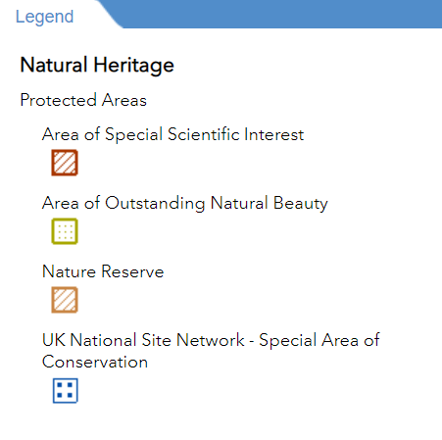
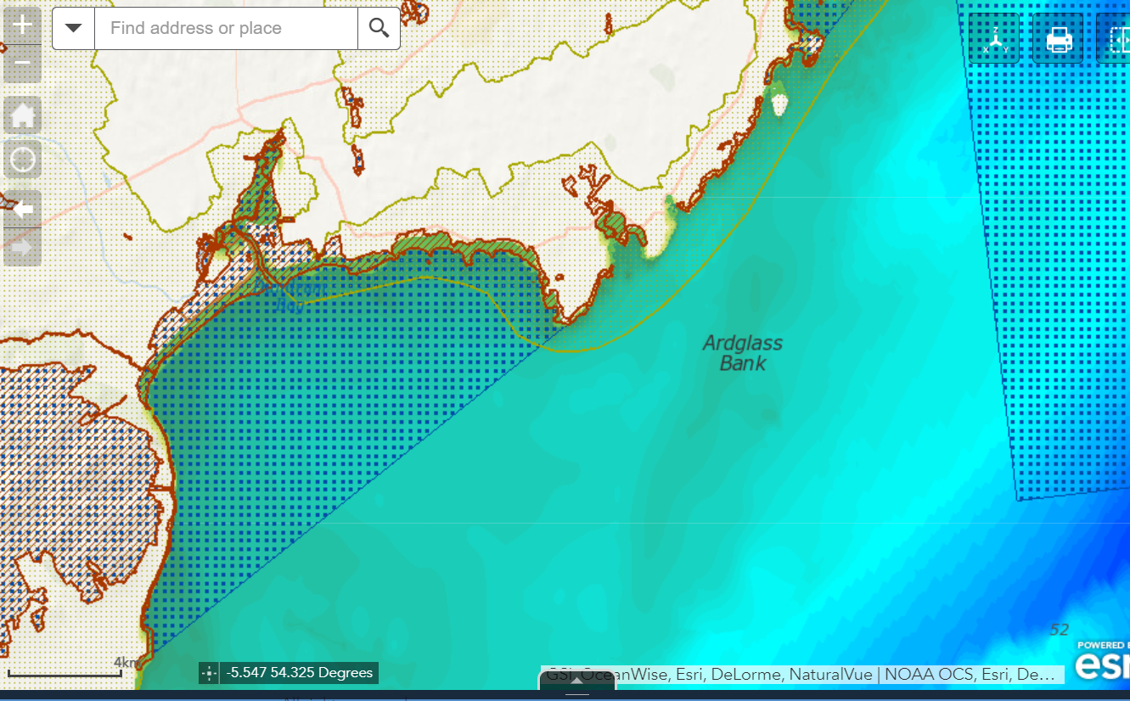
Appendix 1: Map of Marine Protected Areas Murlough SAC MarPAMM Area
Source: DAERA, 2021. Marine Map Viewer

DAERA, 2014. A Strategy for Marine Protected Areas in the Northern Ireland inshore region.
International Union for Conservation of Nature – Dudley, N (Editor), 2008. Guideline for applying Protected Area Management Categories. Gland, Switzerland, p8.
Joint Administrations Statement, 2012. UK Contribution to Ecologically Coherent MPA Network in the North East Atlantic.
DEFRA, 2016. Marine Conservation Zones: Update.
DAERA, 2014. A Strategy for Marine Protected Areas in the Northern Ireland inshore region
All information and Background Context presented in the sections below have been taken from a wide array of DAERA or historic DOENI reports on SACs, ASSIs, AONBs and Nature Reserves.

