MarPAMM Murlough SAC Stakeholder Steering Group Meeting
Date: Wednesday 24 March 2021 Time: 10.00 Location- Online Zoom Meeting
___________________________________________________________________________
Present
Adam Mantell - Ministry of Defence; Ulster Wildlife
Claire Vincent - Marine Fisheries, DAERA
Colin Armstrong - Marine Conservation and Reporting, DAERA
(representing Philip Stewart)
Conor Bush - Keep NI Beautiful
David Morgan - Royal County Down Golf Club
Donal Griffin – Ulster Wildlife
(representing Heidi McIlvinney)
Judith Caldwell - Newry, Mourne and Down District Council (Strangford Lough and Lecale Partnership)
Geoffrey Perrin - Royal County Down Golf Club
Melina Quinn – National Trust
Michael Harkness - Royal County Down Golf Club
Paul Donnan - North Eastern Lobster Fishermen’s Cooperative Society
In Attendance
Catriona Mac Arthur – TCI Engagement
David Stevenson - Agri-Food and Biosciences Institute (AFBI)
Naomi Wilson – Agri-Food and Biosciences Institute (AFBI)
Stephen Hill - TCI Engagement
Apologies
Aideen McChesney - Marine Conservation and Reporting, DAERA
Darren Rice - Newry, Mourne and Down District Council (Strangford Lough and Lecale Partnership)
Joanne Hanna - Marine Conservation and Reporting, DAERA
Martin Carey – Mourne Heritage Trust
1: Welcome and Introductions
DS welcomed participants to the inaugural meeting of the Murlough SAC Stakeholder Steering Group. He explained that the Agri-Food and Biosciences Institute (AFBI) was the lead partner of the MarPAMM project for the Irish region. As the Project Officer, he would be the main contact point for members.
DS then invited Steering Group members to introduce themselves and to highlight their role within their respective organisations.
Unfortunately, Paul Donnan from the North Eastern Lobster Fishermen’s Cooperative Society was unable to participate in this exercise as he did not have access to a camera.
Following the introduction of all members, DS asked everyone to send a short bio and photo to MarPAMM@tciengagement.com by 9 April 2021 and to note in the email whether they would be willing to put themselves forward for the role of Chair of the Murlough SAC Stakeholder Steering Group. A Google Poll would then be held among the membership to elect the Chair.
2: Presentation 1 – Overview of Remit and Administration of Steering Group
C MacA introduced TCI Engagement and explained their role in the project. She provided an overview of the online protocol for steering group meetings, and outlined the role and responsibilities of the group members.
She stressed the need for the Steering Group to be stakeholder led and encouraged members to put themselves forward for the role of Chair (unless a representative from their organisation was already chairing a MarPAMM stakeholder steering group).
C MacA invited members to take every opportunity to promote the project, both by ensuring all relevant interests were represented in the Stakeholder Steering Group and engaging with MarPAMM’s social media; notably through www.facebook.com/MarPAMM and @MarPAMM_project
Documents outlining the ‘Remit and Administration of the MarPAMM Murlough SAC Stakeholder Steering Group’ and the ‘Online Protocol for Stakeholder Steering Group Meetings’ are attached with these minutes, as is a full membership list (as at 31 March 2021).
3: Presentation 2 – An Introduction to MarPAMM Murlough SAC
DS gave a presentation introducing the MarPAMM project to provide an overview to Steering Group members. The presentation outlined:
- The MarPAMM project background and key deliverables;
- An overview of the work packages, their outputs within MarPAMM and the project partners;
- An overview of the MPA Management Plan work package;
- The Murlough SAC part of the project; and
- The expected outputs from the MPA Management Plan work package.
Comments:
CA: Noted the absence of reference to the sand dunes, which are a very important feature of Murlough SAC.
DS: Advised he would amend the presentation to clarify this point.
MQ: Noted the value of DS’s presentation and asked if it could be sent to all members.
4. Discussion Session- What are you initial thoughts of MPA Management
DS: Introduced a group activity using Slido to ascertain the Steering Group members’ initial thoughts on the MPA Management Plan process.
NW: Explained that the Slido online questionnaire is a means of obtaining anonymous responses from participants in relation to the MPA Management Plan for Murlough SAC.
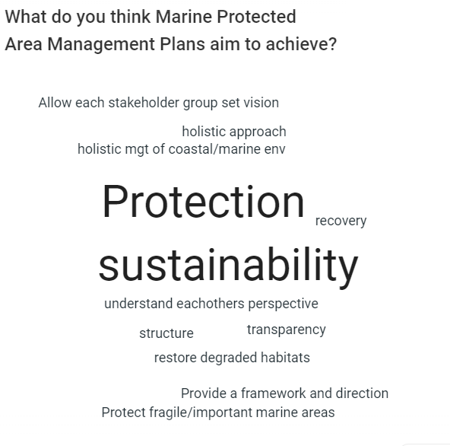
Question 1:

Additional response:
- To look after the marine environment.

Question 2:
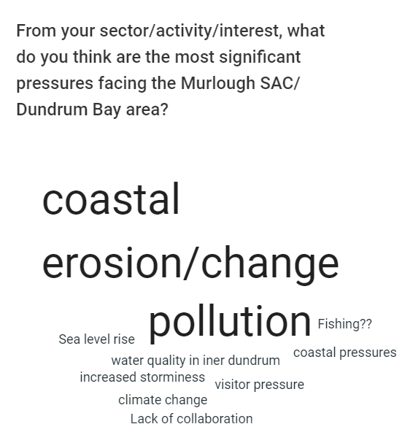

Additional response :
- Pollution and coastal erosion
Question 3
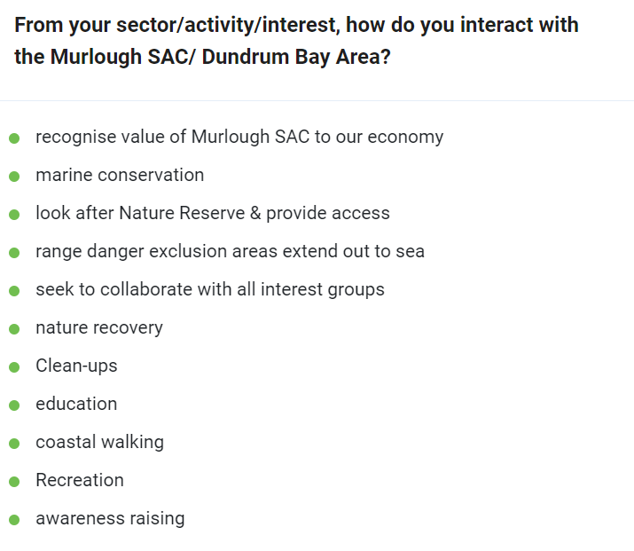

Additional response :
- Fishing lobster, crab and other types of fish.

Question 4

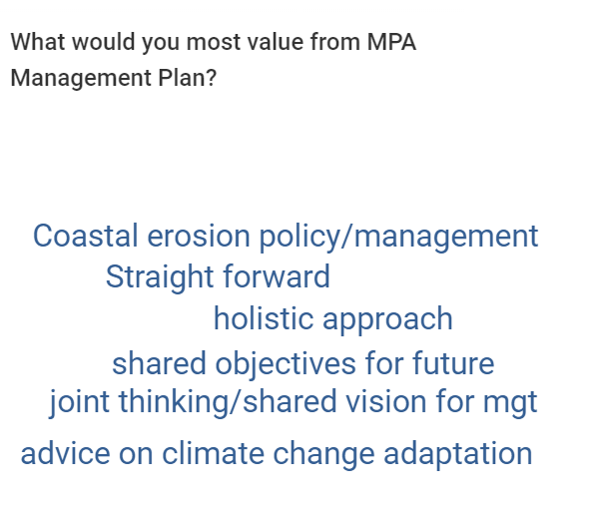

Additional response :
- Depends on what plan is for fishing.
5 Activity Sessions
The Steering Group members were divided into two breakout rooms to discuss what members would value from an MPA Management Plan for Murlough SAC and what opportunities and challenges the plan presents. The project staff reported back to the full group the main themes and perspectives to arise from each of the breakout discussions.
Murlough SAC Digital Breakout Rooms
Room 1 | Room 2
Lead- David Stevenson (DS) | Lead- Naomi Wilson (NW)
Conor Bush (CB) | Colin Armstrong (CA)
Geoffrey Perrin (GP) | Michael Harkness (MH)
Adam Mantell (AM) | David Morgan (DM)
Donal Griffin (DG) | Judith Caldwell (JC)
Paul Donnan (PD) | Melina Quinn (MQ)
 | Catriona Mac Arthur (CMA)

Breakout Room 1: Lead (DS)
Activity 1
PD: The problem with pollution needs to be looked at from the terrestrial perspective, especially recreational litter on beaches, sand dunes and around the coast. This must be expanded further into land/sea cross-over and look at the impacts on coastal processes. Questions on how local fisheries potting and static lines practices impacts are having on coastal processes. What are the conservation/environmental issues coming from the fishing industry in this area?
GP: Our focus is on the long-term viability of the asset of Royal County Down, in Newcastle. Conservation is important but there are some contradictions relating to historic change of sediment within this coastal system. Over the past 70 years there is a clearly witnessed migration of sand, with lower sediments in the Newcastle/Murlough side of Drumdrum Bay, resulting in stoney beaches and aggregation of Ballykinler. Over the past 50 years the groynes around Newcastle have rotted/degraded. We have installed rock armour around the golf course. We do recognise the importance of conservation, not only from coastal defence, but from maintenance of growth within designations. Invasive species management is important to enable native species to thrive, species like Sea-Buck Thorn can take over areas and suffocate food cycles for native species. But our focus is always the long-term proactive management of the golf course.
AM: Although part of Ulster Wildlife, I work with and I am the representative for the Ministry of Defence. The MoD doesn’t comment on activities or plans that have no impact on their work. But from this perspective the plan area is within the Ballykinler Barracks, we have an active interest in how this can affect our work and what the consequences would mean for the MoD. Do the results of coastal processes data impact on the training capabilities of the Barracks? The results from coastal processes studies can help us to look at the consequences of coastal change and erosion. There are erosion issues within the Dundrum channel. Other work I am involved with is maintenance of heath and grassland at Ballykinler. There are big issues with the abundance of gorse, the MoD have spent big money on scrub control.
AM: Discussed the use of the Range Danger Template which creates a 5km exclusion zone out to sea around the firing ranges/practice ranges. These areas enable safe areas where activities/commerce, such as the fishing industry or recreational tourism cannot enter.
DG: This process needs alignment and focus on protecting ecological features with a broadly nature conservation focus. This needs to highlight the land/sea connections, coastal processes and the importance of sand dune features. The process is looking at Benefits Mapping, but have you looked at pressures mapping?
DS: Introductory/background studies have helped to highlight the ongoing and new pressures facing Marine Protected Areas. These are focussed within the work packages looking at sea-birds pressures, marine mammal pressures with noise, pressures with sea-bed habitat change, impacts from coastal processes on the Murlough sand dunes and potential future impacts from climate change (i.e. storm events, erosion, sea-level rise and coastal flooding.
PD: Our organisation represents 40- 50 fishing persons from the North-East of Northern Ireland from the south of Belfast Lough to Carlingford Lough. We have actively worked with AFBI European funded schemes looking at the long-term sustainability of lobster fisheries. Female lobsters carrying eggs are released back into the sea to ensure the continued enhancement of lobster stocks. Dundrum Bay is the main area for lobster fishing/potting in this area. What are the initial thoughts or plan for fisheries in the area?
DS: Balanced approach- looking here at the active perspective of fishing industry and how it fits with other activities/ interests in the area.
PD: Over the past 100 - 200 years there is a line from Rossglass Bay to Roach …… From the 1800s there has been a ban on trawling gear, this is in place and is working within the Murlough/South Eastern Area. Within Dundrum there is fishing for lobster, crab, shrimp, plaice and skate using static gear and mackerel lines. Over the past 15-20 years we have realised 2500 lobsters which has resulted in a species increase of an estimated 50,000. This is to ensure there are sustainable stocks. As an organisation fishing activities and livelihoods are important, but so is the focus on sustainable/ conservation. There is so much data held by Queen’s University Belfast, with regards to lobsters’ DNA. This is very useful and could be useful for this management plan development.
GP: The process needs to take into the consideration the socio-economic perspectives from Newcastle. As part of this I believe it would be important to bring a representative from the Slieve Donard Hotel.
Breakout Room 2: Lead (NW)
Activity 1
What would you value from a Management Plan ?
NW: The work packages will provide invaluable data and will be used to inform coastal management going forward. This will help to reach agreement, which will be a big task but will be very beneficial.
DM: Coastal erosion is a major issue. Should we be looking at soft engineering for coastal defences? Involve Ulster University?
CA: It will be interesting to see the findings of Ulster University’s research. We will soon see a plane flying over Murlough that will hopefully result in a fantastic data set to provide insight into climatic change in the area.
CA: We should also look at the economic case for the area. For example, we should include the economic value that the SAC provides to all; the Council, Royal County Down Golf Club, etc. It also provides a spectacular setting that attracts tourism. This economic case needs to be captured in the management plan.
MH: The golf course has a huge economic impact. It brings in £22m a year; 8,000 American tourists and employs 60 – 70 people. In the summer it also employs 40-50 caddies. American visitors provide 75% of income from the green fee.
The Slieve Donard Hotel should be invited on to this group. They could help inform the economic case.
JC: The area is very important for tourism. With the Covid effect people are wanting to be out in nature more than ever; and they are valuing nature. The management plan has to take into account the need to balance the biodiversity of the area and the need for people to be out in the area.
MQ: People have free access to the site. That in itself brings challenges. It can get very busy on a good day. The Rangers become concerned about the risk of fires from BBQs. The core purpose of the National Trust is to provide public access to the area, but it has its challenges. The MPA plan could help to manage these challenges and manage recreation. The more people there are, the more dog walkers there are… the dogs can disturb the wildlife… it’s very hard to enforce the dog on leash regulation.
CA: A full socio-economic picture of the area needs to be included. This will not be easy to pull together, but that’s why it’s important to have key groups that share objectives.
NW: As regards collaboration between different groups, I’m guessing that Judith (Council) and Michael (Golf Course) already work well together?
JC: I’m not in the Council’s tourism department so not sure how that is working.
JC: It’s very important that aquaculture be represented in this group, and the Mourne Heritage Trust also.
CA: Oyster catchers should also be included.
MQ: A community representative is also needed.
MH: And SOAKS in Newcastle as they are involved in seaweed collection, which has an environmental impact.
MH: The golf course does work closely with the Council on tourism. We have a very good relationship. We also work with them re clearing the beach and the annual golf tournament.
CA: In relation to the representation on the group, we need to think of landowners. For example, the Harbour – who runs it? Does the Council?
JC: Also Tyrella House. And Dundrum Coastal Rowing Club.

MH: We should also include a representative from the Department of the Environment in relation to the treatment plan, and the Department of Infrastructure in relation to the Rock Pool, which is a listed feature. Does the Marquess of Downshire still live in the area?
Activity 2
Breakout Room 1: Lead (DS)
DG: Stakeholder/Steering Group engagement is important, but these are self-identifying stakeholders. The process needs greater stakeholder engagement outside of this group. Have an active presence with the local community. This will heighten the plan’s potential success with interpretations at the site level.
CB: Agree with Donal on the need for wider stakeholder inclusions. Is the expectation there with stakeholders? This could be enhanced through easily explained publications that are easy to understand and clear. For the public this could help to animate and guide.
AM: Certainty- What might be required from us? Movement of infrastructure close to shore is expensive. These projects cost over £100,000, with big timescales and significant impact. These certainties and data to overcome need to be followed within the plan-making process.
GP: Conservation and erosion, plus socio-economic impacts for the local area. This is clear in Newcastle and needs to preserved and enhanced for recreation and tourism. From the perspective of the golf course it is not practical to move the course. Maybe an important component could be to include Chamber of Commerce for Newcastle (interest and setting).
PD: Public, businesses and councillors (the council) need to be part of the engagement process. Need more than just Steering Group advice, clear focus on wider public and interest parties of the Mourne and Newcastle Area.
PD: From a beach perspective there has been no sand along the Newcastle beach front. This change has occurred over the past 20-30 years. Sea-front development and development of sea-armour along the promenade. What impact has this had on the soft system? The south-easterly that often hits the Dumdum bay area is blowing the sand towards Ballykinler. The main coastal defence witnessed in Murlough is the protection of the golf course. Is protection of the course aiding the changes in coastline? With additional pressures on Newcastle.
Wider Notes- Wider liaison engagement will be a certainty and requirement that all the MarPAMM plans will require. This process needs to be transparent and clear to help increase buy-in for guidance and hopefully aid compliance.
Breakout Room 2: Lead (NW)
Opportunities and challenges of the MPA Management Plan for Murlough SAC
NW: One of opportunities we have is to bring in the new stakeholders we identified.
MH: There are so many interested parties here. There will be a lot of people to get the plan past. Is there any way of streamlining this? It would be great to get one body together to be the ‘go to’ body. Who do we go to, for example, if we want to report people using quad bikes, for example?
NW: I agree that it can be confusing to know who to contact and by the time you get to the right person it can be too late. The MarPAMM Management Plan should provide people with this signposting.
MH: Where should people go to if a whale washed up, for example? We need one ‘go to’ person; that would be great.
CA: I often get contacted. I may not be the right person but I do know where to direct people. There should be a core section in all the Management Plans providing contact people; people who have the authority to make decisions . This is a forum for discussion, not a decision making body. But we can signpost. So if you want to apply for planning permission in the area, for example, this is where you should go. We should have this in all the plans.
MH: Challenges include beach erosion. Also, the outflow sewage pipe, which is very unsightly. We want to reinstate the beach, restore sand.
CA: This is a question that is frequently raised with Councillors. Is there a place in the plan for beach nourishment? Is it an appropriate strategy? Researchers met with Councillors and gave a presentation. A long-term strategy is needed; short-term fixes do not work as the restored sand just disappears with the next storm. I am very keen to learn the experts’ views once they have done the modelling.
MQ: The Management Plan will highlight importance of the area. The terrestrial area is well known, but the inter-tidal and marine area is less known. This is an opportunity to promote it and increase awareness of the impact of pressures on the environment. The challenge is to try to get tourists and local residents to care about the natural environment; to be aware of the impact of litter or quad bikes. We need to engage the public and get people to take responsibility for their actions.
NW: We will look at communications in the Management Plan.
JC: The Management Plan is all well and good, but not if tourists and residents cannot understand it. It needs to be accessible so that everyone can understand it. It has to give meaning.
NW: This is why we will be producing benefit maps. We are also looking at interactive story boards, etc. We need to get the science down to the lay level.
MH: People understand the message to pick up their dog litter, but they then leave the bag. Bizarre!
MQ: We should upgrade the interpretive boards, to include information not only on the habitat and species but also on coastal adaptation.
CA: All the separate organisations represented – the National Trust, the Council etc – are very good at displaying benefits to their respective audiences. We need to pitch our messages to different audiences, eg days visitors to the promenade and local golfers. The public do not need the really detailed stuff, but that is needed as evidence for decisions taken. So one size does not fit all in terms of messaging. We need different posters for different sites. We need to adapt our messaging and use formats that people will understand. Our challenge is that we have very different audiences. We need to communicate scientific language in a way that golfers, for example, understand.

6. MarPAMM work for next meeting
- Review, refine and draft presentations and background reports.
- Stakeholder Pen-Pics to be submitted by 9th April 2021.
- Focus on coastal processes for next Steering Group Meeting- Will invite T4 project partners to present on-going work and findings to stakeholders.
- Under take initial benefits mapping and bring the draft outcomes to next Steering Group meeting.
- Invite potential new members to Steering Group based on suggestions from stakeholders.
7. Next meeting date
The next meeting of the Murlough SAC Stakeholder Steering Group is scheduled to be held at 10.00am on 30 June 2021.
DS thanked everybody for participating and for sharing their ideas, knowledge and expertise.

