Irish Regional Steering Group Meeting 1
Date: Monday 23rd November 2020 Time: 10.00 Location- Online Zoom Meeting
Present
Annika Clements- Seafish
Catriona Dowling- Commissioner of Irish Lights
Colin Armstrong- Department of Agriculture, Environment and Rural Affairs
Dave Wall- Irish Whales and Dolphin Group
Ellen MacMahon- Independent
Garry Burrow- Department of Agriculture, Environment and Rural Affairs
Garry Gregg- NI Federation of Sea Anglers
Harry Wick- NIFPP- Sea Source
Heidi McIlvenny- Ulster Wildlife
Joe Smithyman- Crown Estate
John Morton- Causeway, Coast and Glens Borough Council Harbour Master
Kevin Quigley – NI Fisheries Harbour Authority
Martin Graham- NI Tourist Board
Paul Dunne- Department of Agriculture, Environment and Rural Affairs - Food and Fisheries
Philip Stewart- Department of Agriculture, Environment and Rural Affairs
Richard Hill- Royal Yachting Association
Tasman Crowe- University College Dublin
Teresa O’Hare- Causeway, Coast and Glens Borough Council
In Attendance
Adele Boyd- Agri-Food and Biosciences Institute
Alex Calloway- Agri-Food and Biosciences Institute
David Stevenson- Agri-Food and Biosciences Institute
Kathy Graham TCI engagement
Louise Brown- Agri-Food and Biosciences Institute
Naomi Wilson- Agri-Food and Biosciences Institute
Matt Service- Agri-Food and Biosciences Institute
Apologies
Angela Halfpenny- NI Water- Apologies
Harry McKee - NI Federation of Sea Anglers
1: Welcome and Introductions
Matt Service (MS) welcomed the steering group and provided a brief overview of the steering group and the stakeholder process including the potential of monitoring, management aims, management indicators for success. MS then invited Steering Group Members to introduce themselves and to highlight their role.
2: Presentation 1 – Overview of Remit and Administration of Steering Group
An introduction to the administration and remit of the Steering Group Process. Kathy Graham (KG) gave a presentation outlining:
- Introduction to TCI Engagement and their role within the project.
- The Online protocol of the Steering Group meetings.
- The Role and Remit of the Steering Groups:
  - Including Commitment and responsibilities;
  - Role of the Chair and selection; and
  - Project Support.
- Overview of wider liaison, discussion and engagement through:
  - Cycling of Steering Group members from Carlingford SPA and Murlough SAC members to attend this regional steering group.
  - Wider Liaison workshops for 2021; and
  - Social media engagement through Facebook (MarPAMM Irish Regions) and MarPAMM Twitter.
3: Presentation 2 – An Introduction to MarPAMM Irish Regions
David Stevenson (DS) gave a presentation introducing the MarPAMM project to provide an overview to Steering Group members. The presentation outlined:
- The MarPAMM project background and key deliverables;
- An overview work packages, their outputs within MarPAMM and the project partners;
- An overview of the MPA Management Plan work package;
- The regional MPA areas of the project, including example features and areas; and
- The expected outputs from the MPA Management Plan work package.
Additional Comments-
Garry Gregg (GG) - Unique set of circumstances with this pandemic and Brexit, that surely will have enormous potential for MPA improvement and improvements all round (especially the commercial fleet). It’s important that this is taken into account.
DS- Explained that Covid and Brexit have created unique circumstances which the project will take into account. This meeting provides an opportunity of stakeholders to provide important input to steer the direction of management. But their needs to be balance between Covid, Brexit and other important factor within marine protected areas.
GG- From a lay perspective there must be greater potential for improvements based on everybody’s interests, from the perspective with sea anglers or from the commercial fleet there is an opportunity for greater economic benefits.
4. Discussion Session- What are you initial thoughts of MPA Management
Group activity using Slido to find out stakeholders introductory thoughts the MPA Management Plans process and interactions with stakeholders.
What do MPA Management Plans mean to you?
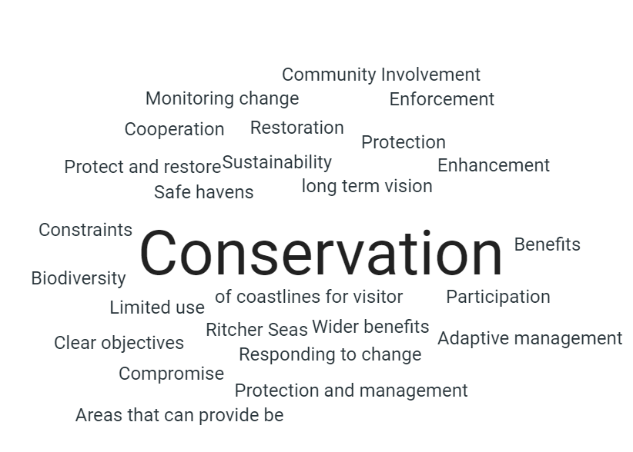
From your sector/activity/interest, how do you interact with MPA's?

  - Environmental impact assessments;
  - Environmental consideration for appropriate assessments;
  - Limited basis from tourism sector to date but via Causeway Coast & Glens Heritage Trust and via councils;
  - Advise;
  - Gaps in protection;
  - Policy Management Monitoring;
  - Fishing industry relocates where possible, suffers loss of revenue where not;
  - Ensure stakeholder engagement for fishing and aquaculture sectors - participatory process;
  - Regulation and protection;
  - Fulfil legal duties;
  - Statutory duties;
  - Discussions with stakeholders;
  - Monitoring from land and sea; and,
  - Evidence.

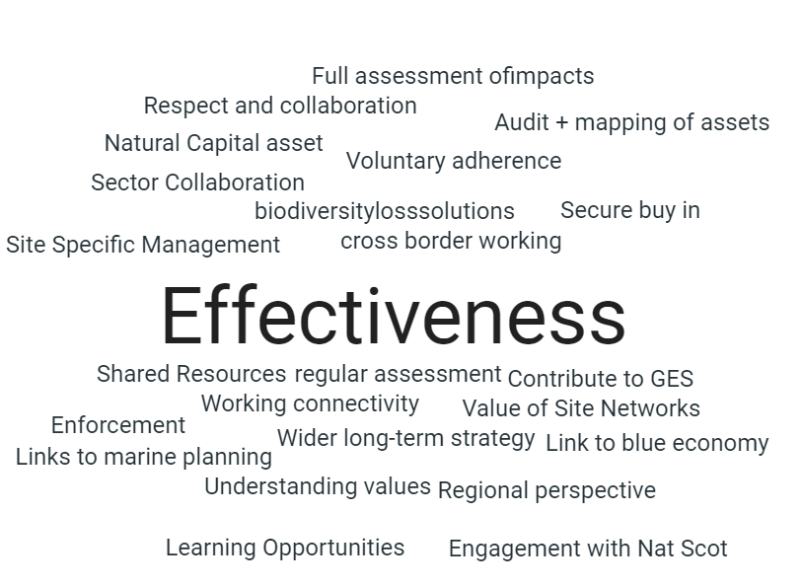
What would you most value from regional MPA Management Plans?

Within the scope of the project do you agree with the feature selected for Management Plans? (Please explain your answer)

- Considering interactions within a system and across features and habitats is important.
- While regional plans have some merit site specific planning and management will still be required to deal with site specific issues.
- Monitoring, evaluating and reviewing the plans will be important.
- Scope of management plans should not be limited to designated features alone.
- By focussing on features that exist across boundaries management can have a wider, more effective reach.
- Agree - feature selection permits MPA management connectivity rather than discrete areas with site selections.
- There is a growing need to move from feature based protection to whole site protection (appreciate this also requires a policy shift).
- Feature selection is good for regional management.
5 Discussion Session- Steering Group Engagement Activities
This session was two activity discussions on MPA Management Plan Development. The Steering Group members were divided into four breakout rooms with MarPAMM project staff to steer discussions. After the breakout rooms, the room leads presented the key thoughts and perspectives of the stakeholders from each of the four breakout rooms.

Group 1 | Group 2
Lead- Naomi Wilson (NW) | Lead- Alex Calloway (AG)
Garry Burrows | Colin Armstrong
Richard Hill | Annika Clements
Kevin Quigley | Martin Graham
Dave Wall | Tasman Crowe
John Morton | John Morton
(observer) Adele Boyd | Louise Brown
Group 3 | Group 4
Lead- Catriona Dowling (CD) | Lead- David Stevenson (DS)
Paul Duane | Phillip Stewart
Gary Gregg | Ellen McMahon
Teresa O’Hare | Harry Wick
Heidi McIlvenny | Joe Smithyman
(observer) Kathy Graham

Activity 1: Opportunities and challenges of MPAs Management
Stakeholder Group (SG) members were asked to discuss their views on the opportunities and challenges of MPAs. The discussions were recorded on flip boards and noted to highlight the main perspectives of stakeholders.
Breakout Room 1: Lead (NW)
What are your views on the Challenges of MPA Management Plans?
- Regional MPA management Plans could permit focus on site specific areas of the marine environment if the voices from those areas are quite strong.
  - The concern is that smaller voices are not heard.
- Tracking of mobile species across different areas.
  - Gaps due to resource limitations that could impact on the modelling that MarPAMM is producing for recommendations in MPA Management Plans.
- A challenge to create an efficient approach that regional management plans may overlook or controversially include sites that overlooked/over included in MPA Management Plans.
- Small voices can be overlooked if opinions from specific regions are much louder.
- Resources are a big concern, stretching resources to cover a wide regional area could increase the loss of protected areas (Sacs, SPAs, ASSIs etc.) within that region
  - Finite resources over large area will affect monitoring and maintenance of a monitoring plan. Could be more beneficial undertaking from a site specific level.
  - Risk of losing areas you would like to protect.
- Potential risk of further impacting fisheries if more MPAs are recommended.
What are your views on the Opportunities MPA Management Plans?
- Using MarPAMM’s objectives for connecting MPA Management Plans is a positive step.
- As the project is Interreg funded and will help to enable cross-jurisdictional recommendations within management plans.
- The application of networks of MPAs helps to achieve resource allocation efficiency.
  - Create a greater opportunity of data sharing between scientists and statutory bodies.
- We can learn from the different MarPAMM regions to create a best practise method which is resource and time efficient.
- The process could contributetowards achieving the 2030 plan for 30% coverage.
Breakout Room 2: Lead (AC)
What are your views on the opportunities and challenges of MPA Management Plans?

Martin Graham (MG): Coastline & assets are a big resource for tourism representing a substantial draw/attraction for international visitors.
A big contribution that MarPAMM could make would be to support closer engagement across sectors, e.g. If new infrastructure, whatever that might be, is planned, can we identify who to engage to get the most widespread perspective from various stakeholders?

Tasman Crowe (TC): Key component of management and restoration is that someone has to lose out. How can we find the solutions towards a best compromise – Everybody feels like they’ve not got what they wanted but accept the outcome.

Annika Clements (AC): Language/terminology can alienate people. Stakeholders don’t have time to analyse the literature produced. I.e. Feature-based management is an alien term to many.
NFFO/JNCC Adaptive management measures workshop was good at breaking down barriers.
Can we produce evidence for closures vs. spill-over to demonstrate effectiveness and rationale for closures? Provide proof that closure would benefit open fishery?

Colin Armstrong (CA): Opportunity for every sector to list their objectives – the RMPAMPs then have to navigate the areas of commonality to achieve something beneficial across the board.

MG/TC: Can we provide an evidence base for each sector? Is there parity in the focus of research/evidence on a sectoral basis?

CA/AC: Need to look at the value of sectors outside of purely economic terms – what is the full socioeconomic picture? Activities can be very geographically constricted so a cessation of activity in one area can have a greater negative effect than in another. Requirement to understand cultural significance of activities/sectors to aid management objectives/decisions.

AC: Good to recognise the links between sectors- e.g. fishing and tourism is growing in NI, 'catch and cook' type businesses. I think Colin made very good points re socio economic assessments and identifying aspirations of each sector first for the local marine environment.
Breakout Room 3: Lead (CD)
What are your views on the Challenges of MPA Management Plans?
MPAs are a fantastic idea, but there is a problem with enforcement and monitoring, eg Greenpeace taking action by dumping large boulders. Vessels do carry AIS equipment to identify these obstructions. The systems are used to input data. Compulsory for certain type of vessels to have this turned on, but there is the capability of vessels to turn these off. Known to happen within fishing industry. This is a weakness in the whole concept of an MPA. Who is monitoring AIS? Is this the call for better enforcement at government department level, with automatic notification of incursions. Maybe a technological solution for this, such as a guard zone, but requires funding for this type of modelling.
Ulster Wildlife is looking to the Fisheries Bill, some testing on the monitoring systems is being done in Strangford Lough. If it is accessible it will be rolled out to the NI fleet. The interaction with fisheries is one of the challenges. There is also a consultation coming up from DAERA about MPA management in fisheries/fisheries management. It was recognised that not all vessels have to carry AIS at the moment. It depends on their activities and size, so using AIS as that medium may prove limited.
Call for real time CCTV to be installed on fishing vessels. Funding again could be an issue, especially if the industry believed this type of system is to be used to introduce sanctions. GDPR considerations too. A fishing licence may be an appropriate lever to ensure installation of monitoring systems, therefore they would incur the cost. Maybe not just about location of fishing but also what is being caught. Need to improve the data collection of what is being caught. Other activities should be included within enforcement, such as anchoring. Robust mechanisms for monitoring are required. Commercial fishing industry need more support and training regarding data requirements and reporting.
But not just fisheries – think about merchant fleet and leisure fleet who also have capability to act in these areas. Shouldn’t just be limited to fisheries. Needs to be on an impact led system.
When designated the MCZ is to recover or maintain and most are to maintain, do we need to take a harder look at this? Is to maintain hard enough? Should it be changed to recover so active management is required in certain areas? Needs to be a two-fold approach. When you introduce anything there has to be a period of education, need to come out with the carrot before you can introduce the stick.
What does the evidence say, where is the damage being done?
What are your views on the Opportunities of MPA Management Plans?
Having a policy opportunity with Brexit. There is a draft Marine Spatial Plan, NI doesn’t have a consented plan yet. Trying to take an ecological based approach. This will form the core of the policy if it is written properly, currently as written in a sectoral way, which isn’t ideal.
How do we make the most of this? - Education, community groups that aren’t industry are important.
Breakout Group 4: Lead (DS)
What are your views on the Challenges of MPA Management Plans?
- Wider representation of marine interested stakeholders outside of this steering group, to make sure that all important views were taken into consideration.
- The impacts and consequences of Brexit post January 2021, and issues with cross-border collaboration and joint working.
  - The practicalities on decision making for a Deal or NO-Deal.
- Baseline evidence for environmental data over the past number of years and the effectiveness of monitoring. Changes on nature within Marine Protected Areas.
- Avoiding tough issues and making sure MPA management Plans actually provide benefits for the marine environment. That it doesn’t become a political tool over the marine environment.
- Making sure there is a balanced approach to working that will provide benefits to all activities and users of the marine environment.
What are your views on the Opportunities MPA Management Plans?
- Protection and positive habitat restoration, with wider benefits in other arena and helps to enhance climatic mitigation.
- Management Plans provide opportunities to a foster a balanced marine development approach.
  - Greater possibilities to understand biodiversity and enhance management through biodiversity mapping.
- Could help to provide enhanced collaboration and knowledge sharing between departments, industries, activities and users etc.
- The application of MPA Management Plans could help to begin the work and achieve the vision of the Northern Ireland Marine Plan. To overcome the discrepancies the publication of the full NI Marine Plan will benefit marine management.
- From the perspective of Top-down and Bottom up wider engagement will enhance the potential of localism and provide a wider representative view.
- From Commercial Fishing perspective the approach could formalise an already co-operative process at the highest level and will help enshrine the rights of activity users.
- The MPA Management Plan process should put the focus on a regional perspective and strive to deliver success for sustainable marine protected areas that work for all activities and users.

Activity 2: What would you value from Regional MPA Management Plans?
SG members were asked to scope the potential perspectives that they would like to see MarPAMM Irish Regions examine? The scoping activity explores some of realistic expectations and potential plan outputs the development of regional MPA Management Plans.
Breakout Room 1 Lead (NW)
What would you value from Regional MPA Management Plans?
- The creation of MPA Management Plans can help us to learn more about noise pollution on cetaceans.
  - The impact on cetaceans from offshore development, pollution and fisheries.
- Significant value in increasing the resilience of MPAs to future climatic change.
  - Improving the maintenance of the MPAs as they are now or enhancing them.
  - Healthy management of prey stocks.
- There are better benefits in approaching management from a wider ecosystem approach aspect rather than species or habitat specific due to the wider marine interactions.
- Changes in the monitoring schedule and reporting schedule for the MPA area.
  - Wider regional monitoring which is more frequent.
  - This could take the shape of improved plans of statutory site monitoring which could attract external funding.
- MPA Management plans contain decisive outcomes with active plan achievements for MPAs.
- Discussion on increasing fish equipment loss causing species mortality increases.
  - Minke Whales are undergoing huge entanglement issues from fisheries within Ireland.
  - A regional management plan led approach for monitoring and managing fishery impacts on cetaceans.
Breakout Room 2 Lead (AC)
What would you value from Regional MPA Management Plans?

MG: A comprehensive SWOT analysis. A demonstration of the strengths and weaknesses of current management of areas with a marine setting.
Momentum is a big factor – The RSG is a good first step but maintaining engagement between focussed meetings will help produce better RMPAMPs.

CA: A truly collaborative effort where volunteers, academic and industrial stakeholders all contribute in towards a common goal. Use this to develop clear actions and accountability for those.

TC: A clear understanding of RMPAMP intentions founded on a clear evidence base.

AC: Can we use equivalent management plans from elsewhere that assess across a regional perspective?
How does resource use work alongside management?
Various sectors have a resource provision: MPAs = conservation resource; prospective wind energy sites = wind resource; prospective tidal energy sites = tidal resource. These resources are protected/earmarked for priority use against other activities. Where is the protected resource for fishing? This seems to be absent at the moment.

TC: It’s the nature of management plans that not everybody’s needs will be met meaning consensus is not a prerequisite of any RMPAMP but we should endeavour to get close to achieving it so that once proposed/enacted they are engaged with by all sectors.

Any RMPAMP needs to demonstrate that it is considering the long-term viability of the sector. Restriction on some activities now (near-future) will provide continued onward benefits maintaining the sector for future generations.
Breakout Room 3 Lead (CD)
What would you value from Regional MPA Management Plans?
- Holistic overall approach is very important. Needs to identify specific groups and overall impact on a region.
- Clear guidance to come out of the plans re impact of some of the activities we are engaged in around the coastline.
- Lifting of buoys and placement of buoys for collection of data.
- Clam dredging – how this impacts on other species is important.
- Anchoring by heavy vessels – DAERA have looked at this and said they are content it’s not doing a lot of damage but Sea Anglers are not so sure. Don’t have the information regarding anchoring in designated areas. Outside of these areas there are no limits.
- Shared learning? Use the opportunity of this forum to sign post others to valuable sources of information.
- Explore extent to which collaboration can underpin research.
- Opportunities to engage via social media between meetings.
- Webinars.
- Make sure engagement reaches a broad scope of stakeholders.
Breakout Room 4 Lead (DS)
What would you value from Regional MPA Management Plans?
- Providing a clear framework for regulators that helps to point users/people towards the correct rules that need to be followed.
  - Within this having a clear monitoring and evaluation framework for MPA Management Plans that is focussed on adaptive management.
- From a spatial data perspective, making sure the spatial perspective and evidence are robust.
- There was endorsement that the MPA Management Plans would need to take into consideration that a positive measure in one area may have unintended/negative consequences/effects another area.
  - The process needs to foster sensible discussions.
- The process for developing MPA Management Plans would need to be open minded, with clear flexibility on location changes if they are required.
- The Management Plan should have a regular review process, which includes a timeline of monitoring and plan review.
  - This could link with the UK Marine Strategy 4 year review.
  - Stakeholders and users need to have clear indication of the monitoring indicators.
- The Management Plan needs a clear outline on what designated MPAs are included and why have these MPAs been designated.
- As part of the plan development process to create a resource or guide to raise weariness and aid acceptable use for activities within MPAs. All the information can be found in one place.
- The use of enforcement with AIS and VMS remote electronic monitoring. (i.e. Look at take outs from fishing vessels).
- From a societal-economic perspective there is limited mechanism for smaller vessels on what is their takeout and is there potential for electronic monitoring to enhance the Scio-economic potential of the MPA.
  - We need to know what we take out of marine areas and their value.
  - The undertaking of a Scio-economic Assessment of the MPA Management Plans.
- The link between good ecological status and good environmental status to help enhance the resilience for sustainable development.
6. Next Steps
DS moved the discussion onto next steps and highlighted the initial date of the next Steering Group Meeting for February 2021, as well as asking members to forward potential agenda items. DS then passed over to KG for final summing up and to move the meeting towards closure.
KG: Could stakeholders please forward dates in February 2021 that they are unavailable.
KG: We would like to continue this conversation and discussions outside of this meeting, we don’t want silence between now and the next Steering Group Meeting in February 2021, so we would encourage you to follow and be active on the social media pages.
KG: Please forward your pen pictures/ short bios to us and we will circulate to the other members to aid the selection of a Steering Group Chair.
KG: At the next meeting we will get a project update from the work packages and provide an update on the progress of the Carlingford SPA and Murlough SAC Steering Groups, with a nomine from each group present.
KG Summed up and highlighted the group’s desire for collaboration and close working. Everybody has set the time aside today to be part of this and people want to participate. We greatly value your time, knowledge and insights. We want get some momentum behind this group and to keep these conversations going because its only by building the relationships and trust amongst us all that we will get that effective collaboration.
KG: If anybody would like to propose any items for the next agenda you will have time to reflect on the minutes from this meeting and propose ideas and thoughts.
KG: Any other Question or Any Other Business?
GG: This group needs to make sure there is a community representation. It would be beneficial for the group if invites are forwarded for the next meeting to enable further representations from coastal communities.
DS: Final reminder of MarPAMM webpage, social media and MarPAMM Irish Regions Facebook page.
DS Final thanks to Steering Group participants and closure of the meeting.

