MarPAMM Irish Regions Carlingford Lough SPA Steering Group Meeting
Date: Friday 27th November 2020 Time: 10.00 Location- Online Zoom Meeting
___________________________________________________________________________
Present
Anika Clements- Seafish
Bernarde Kilgallon- Residents Group Carlingford Lough Area
Brenden McSherry- Louth County Council
Catriona Dowling- Commissioner of Irish Lights
Darren Rice- Strangford Lough & Lecale Partnership- Newry, Mourne and Down District Council
David Holmes- Warrenpoint Harbour Authority
Irene Hamiliton- Carlingford Lough Ferry
Jennifer Cumming- East Coast Adventure Ltd
John Doran-
Judith Caldwell - Strangford Lough & Lecale Partnership- Newry, Mourne and Down District Council
Kian Louet-Feisser- Carlingford Lough Oyster Company
Kenny Boodles- Royal Society for the Protection of Birds
Mark Cumming- East Coast Adventure Ltd
Martin Flanigan- BIM
Niall McCarthy- Greenore Harbour Authority
Olivia McCartan- Love your lough
Phillip Stewart- Department of Agriculture, Environment and Rural Affairs
In Attendance
David Stevenson- Agri-Food and Biosciences Institute
Kathy Graham- TCI engagement
Naomi Wilson- Agri-Food and Biosciences Institute
Apologies
Sarah McLean- Loughs Agency

1: Welcome and Introductions
DS welcomed the steering group and laid out the online house rules for the event. DS provided a brief overview of the steering group and the stakeholder process. DS then invited Steering Group Members to introduce themselves and to highlight their role.
2: Presentation 1 – Overview of Remit and Administration of Steering Group
An introduction to the administration and remit of the Steering Group Process. KG gave a presentation outlining:
- Introduction to TCI engagement and their role within the project.
- The Online protocol of the Steering Group meetings.
- The Role and Remit of the Steering Groups:
  - Including Commitment and responsibilities;
  - Role of the Chair and selection; and
  - Project Support.
- Overview of wider liaison, discussion and engagement through:
- Lines of communication between the three MarPAMM Irish Regions Steering Groups with a member from the Carlingford SPA and the Murlough SAC Groups attending the Irish Regional Steering group Meetings.
  - Wider Liaison workshops for 2021; and
  - Social media engagement through Facebook (MarPAMM Irish Regions) and MarPAMM Twitter.
3: Presentation 2 – An Introduction to MarPAMM Irish Regions
DS gave a presentation introducing the MarPAMM project to provide an overview to Steering Group members. The presentation outlined:
- The MarPAMM project background and key deliverables;
- An overview work packages, their outputs within MarPAMM and the project partners;
- An overview of the MPA Management Plan work package;
- The Carlingford SPA Area of the project, including cross-border perspective and example features and sites; and
- The expected outputs from the MPA Management Plan work package.
Comments –
DS- Mapping clarity- The Northern Ireland and RoI maps to be refined into one map work package map.
Question- The map only shows the SPA on the Northern/Northern Ireland shore?
DS- The map is presentation isn’t the clearest with the southern SPA area and a new map will rectify this.

4. Discussion Session- What are you initial thoughts of MPA Management
DS- Group activity using Slido to find out stakeholders introductory thoughts the MPA Management Plans process and interactions with stakeholders.
NW- Slido is a way for us to get an anonymous survey results from you the stakeholders. It’s a series of questions to garner what you would want from the Steering Group and from the MPA Management Plan MarPAMM is developing.
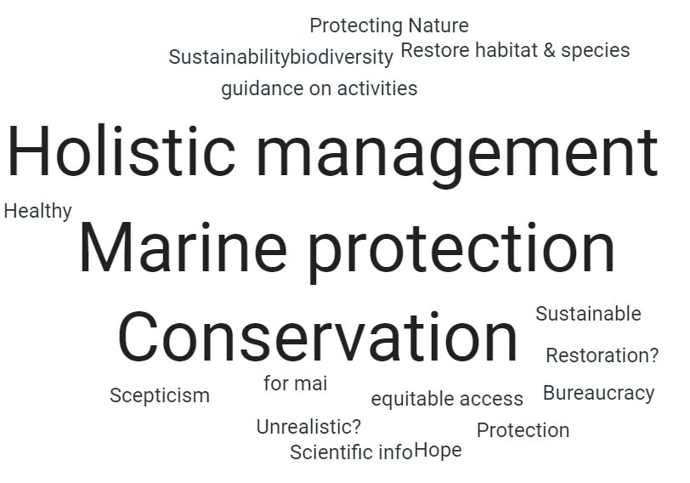
What do MPA Management Plans mean to you?

From your sector/activity/interest, how do you interact with MPA's?
- Dolphin watching.
- Protection of coastline.
- Support understanding of positive effects.
- I believe our aquaculture adds to the marine ecosystem, like a reef our underwater structures provide habitat I increase in wild life adjacent to us.
- Planning (development management).
- Environmental protection.
- Education.
- Birdwatching.
- Looking after it ensure socioeconomics are considered.
- Statutory consultation consideration.
- Promote public engagement.
- Licensing in aquaculture.
- Canoeing.
- Protection and conservation.
- Industry/Conservation facilitation.
- Cycling.
- Restoration of features and raise public awareness as required.
- Work within designations.
- Walking.
- Monitor.
- Recreation.
- Regulation and monitoring.
- Educate, raise awareness.
- Wildlife disturbance management.

What would you most value from MPA Management Plan for the Carlingford Lough SPA?

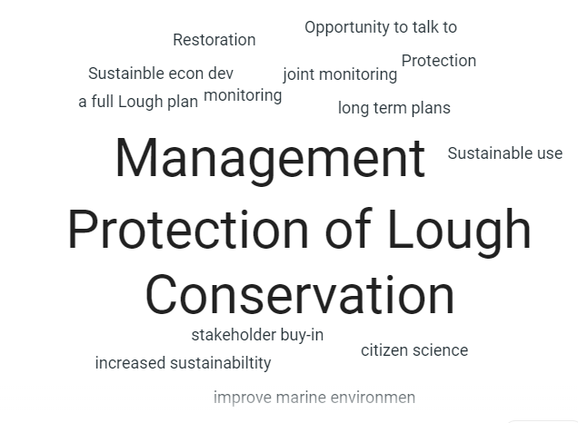

5 Discussion Session- Steering Group Engagement Activities
This session comprised a set of two activity discussions on MPA Management Plan Development. The Steering Group members were divided into three breakout rooms with MarPAMM project staff to steer discussions. After the breakout rooms, the room leads presented the key thoughts and perspectives of the stakeholders from each of the four breakout rooms.
Carlingford Lough SPA Digital Breakout Rooms

Room 1 | Room 2
Lead- Naomi Wilson | Lead- David Stevenson
Catriona Dowling | Irene Hamiliton
Kian Louet-Feisser | Brendan McSherry
Judith Caldwell | Darren Rice
Phillip Stewart | Kenny Boodles
Anika Clements | Mark Cumming
Jennifer Cumming | Olivia McCartan
Room 3
Lead Kathy Graham
David Holmes
Niall McCarthy
Dr Sarah McLean
Martin Flanigan
Bernarde Kilgallon
John Doran

Breakout Room 1: Lead (NW)
What are your views on the Opportunities of MPA Management Plans?
- This SG meeting is giving stakeholders an opportunity to give their opinion on what they would like from a management plan.
- Potential to think about Lough wide management that could be extended over the long-term.
  - This is of great value as there has been some comment of territoriality of some areas, especially when from a cross-border perspective.
  - This would help to connect discrete areas.
  - A Lough Wide management plan addressing these concerns would be extremely positive.
- This Steering Group allows stakeholders to discuss and engage from series of different backgrounds and knowledge areas, but with similar interest in the Lough.
- Listen to and acknowledge every stakeholder, and anticipate that there is going to be some comprise needed between activities.
- A management plan with a clear distinction that can pinpoint governing agency/place to go for points of contact from both sides of the border for dealing with issues or whom to contact if something needs to be notified.
  - Hopefully this plan can help to achieve this and provide the detail of whom needs to be contacted.
What are your views on the Challenges of MPA Management Plans?
- As there are so many voices within Carlingford and there are so many discrete areas being protected under different levels of legislation, there is a challenge to have clear vision and objectives for the MPA Management Plan that will meet stakeholder expectations for the Carlingford SPA area.
- What will be the benefits to all stakeholders across the Lough as there are a lot of different activity users within the area.
  - It is going to be difficult to incorporate everyone’s views into one plan this process going to create a balanced approach?
  - Asking for compromise will be difficult but hopefully can be achieved.
- Historical protection by some stakeholders of discrete areas
- Difficult getting decision powers due to cross-border regulators and for dealing with issues.
Breakout Room 2: Lead (DS)
What are your views on the Opportunities of MPA Management Plans?
- Management Plans provide an opportunity to enhance the conservation objectives and maintenance of site.
  - This needs to take into account on how the MPA Management Plan for the Carlingford Lough SPA will maintain features.
    - The management plan needs to set out clear objectives and deliverables.
  - The Management Plan needs to show how the management works and to have an effective monitoring process in place.
    - There is a chance through the monitoring process to set out clear achievable objectives with key deliverables.
    - This will show how well the management plan works and enable some supporting benefits mapping to review plan effectiveness.
- The management plan process is reactive and could provide a dynamic tool which can help overcome or to be seen as a paper park barrier for biodiversity enhancement in the area.
- Carlingford Lough is underfunded from a tourism perspective compared to other similar areas around Ireland, including Strangford Lough.
  - Green tourism could provide a good attraction and help to overcome the underfunding.
  - There is the potential for organisations such as Bord Fáilte to enhance tourism projections for the Carlingford Lough area.
  - The area has good infrastructure links, towns/villages and residents.
- The Management Plan needs to set out clear objectives and deliverables for activities and users.
- The MPA Management Plan needs effective monitoring from a short-term 5 year perspective and long term from 10years.
  - The MPA Management Plan needs to take into account the activity user, look at all the economic and biodiversity elements needed to support long-term sustainability and to help improve the overall joint outlook.
- Early engagement between users and this forum is a good opportunity with the management plan process.
- From an industry perspective all those working with ports try to engage as early as possible. All activity users have a responsibility to engage.
  - The harbour has engagement with all relevant agencies and to further sustainability of the Lough in Warrenpoint there have been storyboard and audios installed to further education on ecosystem importance.
  - The ports have a commercial reality but they try to balance to do more environmental commitments.
- There is an opportunity for learning from international examples of Slovenia and their natural environment considerations for this type of Lough ecosystem.
What are your views on the Challenges of MPA Management Plans?
- Balance between industry development and conservation, the management process will need to show how industries and developments can get alignment.
- A key perspective from this Steering Group is that early engagement is important between industries, businesses and residents.
  - The plan needs to take into consideration and recognise that activities and users will need discussion and compromise.
- Issues between waste water with the harbour developments and housing in towns and villages.
- Complications from a cross-border perspective within marine management.
- Balance between industry development and conversation.
- The plan needs a clear vision, clear aim and clear objectives.
Breakout Room 3: Lead (K )
What are your views on the Opportunities and Challenges of MPA Management Plans?
- Carlingford is a great place to live and tourism is growing. The area should be promoted as a shellfish producing centre through PGI or promotional events.
- Licensed aquaculture is important.
- Concerns were raised about the management of mussel dredgers. Who is responsible for their management and who can be turned to when residents on the shore of the Lough have an issue?
- It was noted that public fisheries do not benefit from controlled areas.
- There is a difference between shellfish farming and shellfish fishing.
- Compare the Carlingford area to Padstow. Carlingford has the potential to match Padstow in terms of quality produce offerings.
- In terms of the environment water quality is a big issue. Shellfish is reliant on good water quality, therefore the issues are not in conflict. The promotion of a clean healthy environment and water quality will benefit shellfish industry.
- Carlingford is an area to enjoy and promote. Healthy natural tourism and the environment are vital.
- Enforcement is vital, but who is responsible? Environmental crime is a big issue.
- There needs to be equitable and quality access and the peaceful co-habitation of users of the Lough.
- The MPA needs to be data led.
- Water quality has been on the decline.
- Sewage on the Omeath side? The 15 residents along the shore all have septic tanks.
- There is the Interreg SWELL Project which is investing money into infrastructure. A presentation on the project and how it relates to MarPAMM would be welcomed at a future meeting of the Stakeholder Steering Group.
- There is a PGI for all island Beef can this be explored? Is there a PGI opportunity for shellfish?
- A big opportunity is the all island EU trading zone.
Activity 2: What would you value from Regional MPA Management Plans?
SG members were asked to scope the potential perspectives that they would like to see MarPAMM Irish Regions examine? The scoping activity explores some of realistic expectations and potential plan outputs the development of regional MPA Management Plans.
Breakout Room 1: Lead (NW)
What would you value from a Carlingford Lough SPA MPA Management Plans?
- Ensure common enjoyment and utilisation of Lough while ensuring conservation efforts are maintained.
- Quite a discussion on public education and awareness of responsibilities.
  - Your actions may influence marine species or other areas.
    - Example from Commissioner of Irish Lights, if you drop your anchor here eve if it’s once a month that could have an impact on as species or area, even after such time small periods.
    - This awareness can help users to be more responsible for their own actions.
    - Use of lay persons/common language can help to work with people rather than lecturing them for compromise.
    - The need to engage with other likeminded stakeholders.
- Commercial sustainability of industries like fisheries/farming to be productive while ensuring conservation efforts are achieved.
- There needs to effective guidelines or person of responsibility over certain areas.
  - Challenge of enforcement due to institutional constraints in Northern Ireland.
  - Who enforces the law on the Lough?
  - Awareness of organisational/agency responsibility for the Lough, i.e who do you contact if a pollution event occurs on the Lough?
- Benefit with compromise, guidance on joint approach for multiple uses within the SPA for activity users.
- Protection of SPA features for benefits to all and for all lough areas or users.
- Review work from other projects and apply lessons learnt to improve and enhance this management plan approach.
Breakout Room 2: Lead (DS)
What would you value from a Carlingford Lough SPA MPA Management Plans?
- More scientific evidence from mussel dredging, how is the process monitored?
  - What is the licencing process?
  - The area can be considered as a free-for-all for mussel dredging machines =.
  - There has been limited analysis on the impacts, but there is evidence of lots of broken mussel shells on the shoreline.
  - Where is mussel spot within the Lough and is there any risk from invasive species?
  - The group is not saying stop all mussel dredging activity, but can it be done sustainably.
    - Stakeholders have expressed that there seems to be a reduction in diving duck numbers within Carlingford Lough.
    - What is causing this issue?
      - What is monitoring considerations for vessels, especially smaller ones operating in these areas? Limited trawling monitoring requirements.
- From an industrial perspective developmental pressures in relation to planning.
  - Questions on development planners following regulations and balancing the need for industry and biodiversity enhancement.
- The impact of surveys and seal counting surveys on Carlingford Lough
  - These surveys or monitoring periods could be achieved through vessel AIS monitoring while dredging.
  - Comparisons with Strangford Lough for the use of management regimes for features like the Horse Mussel with the creation of limited catch or no catch zones.
- The role of the management plan and the potential for remote monitoring in line with the Joint Fisheries Statement.
  - This includes looking at the connectivity of the management plan with other legislative requirements and higher level policies.
    - There needs to be a clear pathway with policies including from a fisheries perspective.
- Raise public awareness and foster a sense of local ownership.
  - Establish a process to find out who the regulator is to deal with conflicts or issues.
  - This Steering Group can help enhance and create local ownership.
- Who is responsible for different activities? There is a potential to create an awareness document that sets out the remit and responsibilities for agencies from both sides of the border.
- Impact of residential development and has the impact of Septic tanks ever been studied or quantified within the Lough environs?
- Steering Group outlined the potential for the Loughs Agency to become more of an overall coastal management provider or competent management agency.
Breakout Room 3: Lead (KG)
What would you value from a Carlingford Lough SPA MPA Management Plans?
- Be clear about what is in scope.
- Develop a framework, with a balanced approach and use it to consult. Ensure there isn’t a monopoly of issues/ ideas of stakeholders.
- One of the examples discussed is to improve the water quality of the Lough – historical issue.
- When everyone comes together good decisions can be made.
- Dredging: deeper channel on approach to harbour would allow bigger ships, therefore less traffic or would it mean more bigger ships?
- There are other consequences of larger ships such as bow waves on the shore and the impact caused such as erosion.
- Need to have a focus on protection of the natural environment and biodiversity
- Protection of the coastline – consider increase in storm frequency, erosion, high tideline and climate change.
  - Currently the residents are protecting the coastline from wear and tear.
- Consider shipping versus aviation.
  - 90% of goods to Northern Ireland enter via shipping.
  - Shipping is much more carbon friendly than aviation.
- There is a lot of commitment to Carlingford Lough and a strong sense of ownership by the local community.
- There is recognition of the importance of the Lough.
6. Next Steps
DS- The notes and discussion points taken from the Slido discussion and from the two engagement activities will be used to inform the initial piece of benefits mapping. And to help shape the direction of the management plan based on stakeholders perspectives.
DS- Over the next weeks we will review the video, discussion outputs and notes from the three breakout rooms. We will forward to all stakeholders as minutes.
DS- If any stakeholders have any questions or any information they wish to add please email the project officer david.stevenson@afbini.gov.uk.
DS- The Steering Groups are proving really valuable for getting to know the issues and management perspectives of stakeholders that are important in an area. I would be interesting in the lon-run of this stakeholder process to see if the approach taken in this group is in agreement with the approach taken in the Regional or Murlough SAC Steering Group.
DS- We would like to continue this conversation and discussions outside of this meeting, we don’t want silence between now and the next Steering Group Meeting in February 2021, so we would encourage you to follow and be active on the social media pages. Uploads of the past Word Clouds from the Regional Steering Group are on the MarPAMM Irish regions Facebook page and we would like to see if you think these are similar to the Carlingford SPA area?
DS- moved discussions to rounding off and summed the discussion points up.
- Useful to see the background interests of what MPAs mean to stakeholders and how to stakeholders interact with them;
- The opportunities and importance of active management through an MPA Management Plan;
- The need for a balanced management approach;
- The importance of the Lough to the local community, businesses and residents;
- The limited promotion of Carlingford Lough from a tourism perspective and hpw this could be overcome in the future;
- Linkages between the policy hierarchy and the management plan;
- The importance or early engagement and engagement from a wide array of different stakeholders;
DS Thanks for your initial engagement and discussion this morning. This is an important process and we want this to grow as much as possible.
KG- Thank you all for your time. Your commitment and passion has shown through in the discussions. There is huge recognition of the importance of the Lough with a real sense of ownership.
KG: Please consider your pen pictures/ short bios to us and we will circulate to the other members to aid the selection of a Steering Group Chair. It’s important that this group is stakeholder lead.
KG: Good ideas for agenda items or getting external people to present and possible additional stakeholders added to the next meeting. Any other agenda for the next Steering Group meeting which will be held at the end of Funerary 2021 please let us know. As could stakeholders please forward dates in February 2021 that they are unavailable.
KG- Final thanks to Steering Group participants and closure of the meeting.

