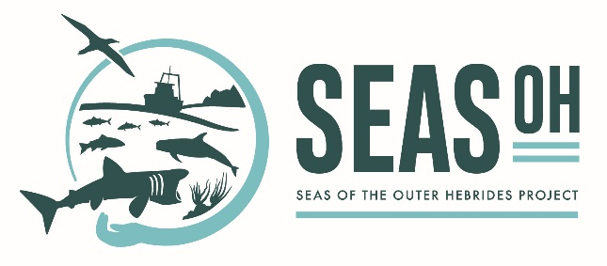

A Regional Marine Protected Areas Management Plan for the Outer Hebrides: Scope of MarPAMM - SEASOH
Last updated: June 2020
Document Purpose
The Marine Protected Areas Monitoring and Management (MarPAMM) project has been created to develop science, tools and plans to deliver effective management and monitoring of Marine Protected Areas (MPAs) across several regions of Scotland, Northern Ireland and Ireland. Seas of the Outer Hebrides (SEASOH) contributes to the work package of the MarPAMM project that will deliver MPAs management plans for these regions. The work of SEASOH is overseen by a working group of representatives from partner organisations: Scottish Natural Heritage (SNH); Comhairle nan Eilean Siar; Marine Scotland (MS) and the University of the Highlands and Islands, Lews Castle College (UHI). The World Wide Fund for Nature (WWF) was also involved for approximately the first year of the project.
In this document, agreed outcomes following initial meetings by members of the project working group are summarised, with the resulting defined scope that the MarPAMM - SEASOH project has in order to consider management of Marine Protected Areas (MPAs) in the Outer Hebrides Marine Region (OHMR). The project aims to develop a plan with the right balance between expectation and results that can deliver positive change for communities and stakeholders while maintaining and strengthening the integrity of the UK MPA programme as a whole. Agreed scope will be reviewed as needed by the project working group. See also the SEASOH working group’s Terms of Reference, which outlines governance of the group and project.

- Awareness, Education and Cultural Heritage
A central aim of SEASOH is to aid a better understanding and awareness of cultural heritage, and the marine environment natural heritage that so deeply links people to the sea. This will result in a more effective and inclusive plan and facilitate better decision making. The project aspires to increase and collate knowledge on these themes and will lead on the development, collection and presentation of relevant information in format(s) accessible to their target audience(s).
- Areas contributing to marine nature conservation priorities within the Outer Hebrides Marine Region.
The MarPAMM – SEASOH project’s focus includes all discreet geographical areas identified as contributing to the Scottish Government’s marine nature conservation priorities in the OHMR. The existing MPAs, proposed MPAs and proposed Areas for Management Consideration (AoMC) that are within or partly within the OHMR will be included within the scope of sites considered by the project (Figure 1; Annex A).
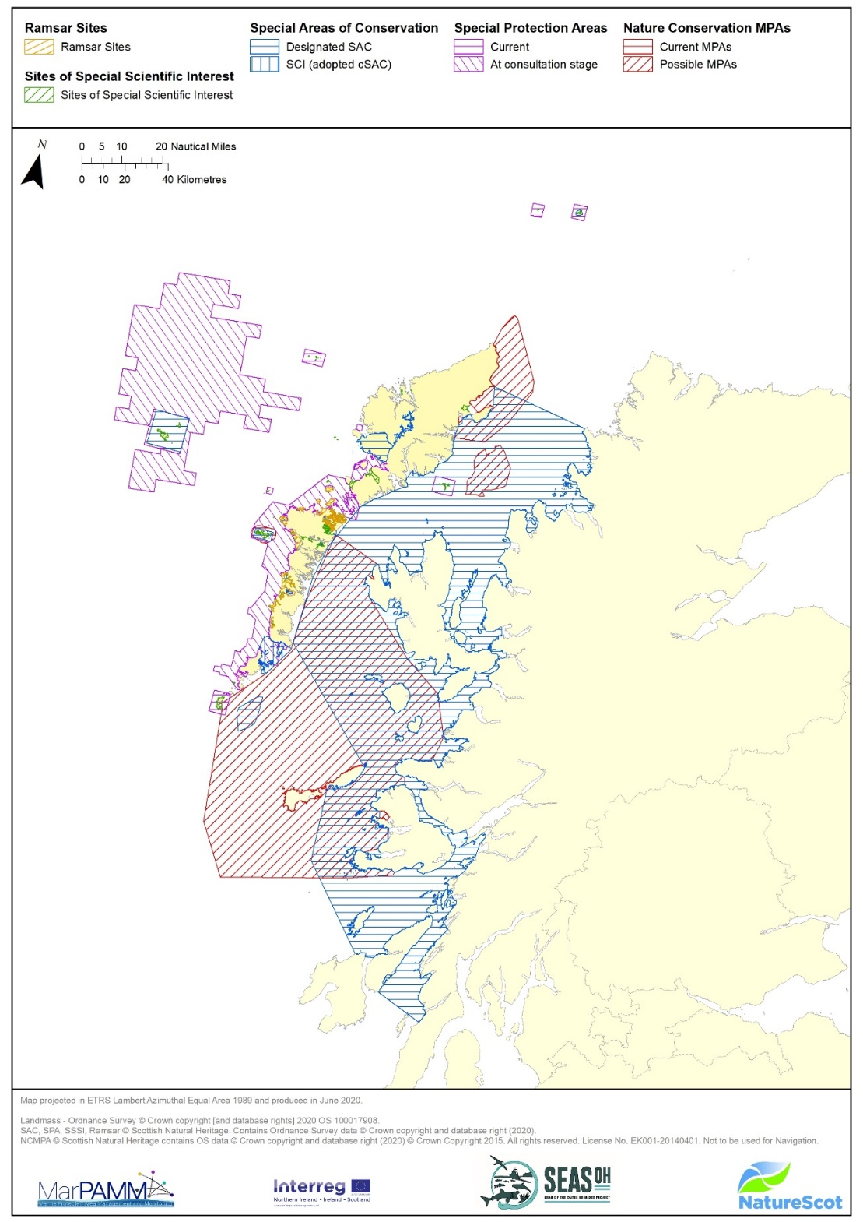
Figure 1. The Outer Hebrides Marine Region, showing existing MPAs and the three possible MPAs consulted on in 2019.
It is possible that our community engagement may identify a subset of these sites which would be prioritised in the first iteration of a management plan. Ultimately, sites could be grouped in sections of a management plan for ease of communication about management priorities.
The MPA sites list for SEASOH (Annex A) has been identified to include all protected areas that either have marine or inter-tidal features, or their features include species that have a dependence on the marine environment for at least part of their lifecycle. Where a site has multiple features, its inclusion in the provisional list is suggested on the basis that the plan will only consider those features with marine connectivity.

- MPA Boundaries and Features
As communities and marine users become more engaged in the project there may be occasions where the boundaries or features of existing MPAs will come into focus. The purpose of SEASOH will be to listen to and represent community views, however it will be beyond the scope of the project itself to revisit the designation orders. The Scottish Parliament has established a six yearly review cycle which considers how effectively the MPA network contributes to the Scottish Government's vision of clean, healthy, safe, productive, biologically diverse marine & coastal environment, managed to meet the long-term needs of nature and people. That review also considers socio-economic effects and an analysis of management measures and compliance. Issues relating to MPA boundaries and features that are raised over the course of the MarPAMM - SEASOH project will be captured by Marine Scotland to inform the parliamentary review process.

- Setting of conservation objectives
Part of the collaborative approach to developing a Regional MPAs Plan will involve the development of a community-led vision on the management or use of the seas within the OHMR. While there is no clean slate in terms of policy, management and regulation, the objective of the project is to faithfully represent local aspirations.
Scotland is currently reviewing the approach to setting MPA conservation objectives. Whilst focussed on the Natura sites (SACs and SPAs), any new guidelines developed through this project will be extended to the NCMPAs, SSSIs and Ramsar sites to ensure consistency across the MPA network. Conservation and Management Advice (CMA) documents are currently being developed by SNH and will be adopted as they are finalised. The documents will contain details on a site’s conservation objectives, feature sensitivity, pressures from activities and proposed management measures. SEASOH will capture community aspirations for the site alongside those statutory information requirements.
The East Mingulay SAC CMA was the first to be completed and is now published online. The format is by necessity technical to meet the legislative requirements. SEASOH will explore ways to best make the information they contain accessible to the general public.

- Existing fisheries management measures
While we propose that existing fisheries management measures will not be formally reviewed by the project, there is considerable scope for the project to influence the development of measures for MPAs and for PMFs within the region’s proposed Areas of Management Consideration.
The first tranche of management measures were introduced to ‘priority’ MPAs in February 2016. This was done generally on the basis of the presence of the most sensitive benthic habitats and species. These are commonly referred to as the ‘Phase One Fisheries Management Measures.’
It is too early to say if the phase one measures are being effective in helping to deliver the conservation objectives of the MPA network either within the Outer Hebrides Marine Region, or across Scotland as a whole. The Marine Protected Area Network – 2018 Report to the Scottish Parliament commits to reviewing the impact of current management measures by 2024. Scottish Natural Heritage has established a number of monitoring sites throughout the OHMR and beyond, that will enable us to compare managed and non-managed sites to evidence the effectiveness of management across a range of habitats.
Phase one measures were developed on a site-by-site basis and were informed by SNH advice on the sensitivity of the protected features associated with an MPA. They were consulted upon in 2014 and introduced in February 2016. In the OHMR the sites where management measures were brought forward in phase one were East Mingulay SAC and St Kilda SAC. The proposals for management measures gave rise to concerns in the Outer Hebrides principally about the potential socio-economic impacts on fishing communities.
SEASOH needs to be able to address concerns such as those expressed over East Mingulay SAC in some meaningful way. To do so we propose the following:
- We establish the basis by which SEASOH can inform the proposed review of management measures in 2024, and properly capture community aspirations.
- We establish a mechanism whereby innovative approaches to alternate management options (as proposed by the community) may be trialled to inform that or subsequent reviews. It’s envisaged that these trials would need to secure funds from an external source. It is unlikely that the project will be able to develop proposals, secure funds and run trials within the lifetime of MarPAMM (i.e. before 2022). However, the project could act as a catalyst to identify and instigate these separate work streams.
- The project seeks to explore options for diversification and other potential mitigation options that would off-set any negative socio-economic impacts associated with MPA management measures. The project will initially need to better understand and detail impacts while also acting to help develop and secure proposals that are identified by the community (and if necessary secure funds from external sources). Options could include (but are not limited to) the adoption of alternate fishing gear, diversification into new or under-utilised fisheries or towards more sustainable fisheries, increasing value of catch, participation in MPA monitoring programme. The project will consider options across the marine region and invite suggestion from key stakeholders such as the Outer Hebrides Inshore Fisheries Group (IFG).
There is an extensive existing suite of fisheries management measures within the Outer Hebrides Marine Region that has been developed to promote interests not directly relating to marine nature conservation. Usually these measures are designed to benefit a particular fishery or increase operating efficiency between different fisheries. It is not intended that the detail of all fisheries management measures will be considered within the scope of the project.

- Future fisheries management measures
  - Phase Two sites and Priority Marine Features
“Phase two” of the fisheries management measures consultations relate to Priority Marine Features (PMFs) and a further set of already designated sites (Sound of Barra SCI, Loch nam Madadh SAC, North Rona SAC and the Monach Isles MPA). These management measures are due for public consultation as soon as practicable. The Outer Hebrides inshore Fisheries Group (IFG) has agreed to the establishment of a sub-group that will provide a mechanism to allow facilitation by SEASOH, wherever possible, to represent community views in the development of future fisheries management measures.
SNH was commissioned by MS to identify locations where there is a need to consider additional fisheries management measures to ensure there is no significant impact on the national status of Priority Marine Features (PMF). Eleven PMF habitats have been recognised as being particularly sensitive to impact from bottom contacting mobile fishing gear. Several areas within the OHMR have been identified as containing a significant extent of one or more of these features. Similar to the proposal for the development of management measures for the phase two sites, it is intended that the forthcoming consultation will seek a view on the desirability of SEASOH leading on the development of measures designed to secure the status of the identified PMFs in the region. For further details including SNH advice on the 11 selected sensitive PMFs see LINK

  - Other MPAs/pMPAs and relevant management
Further to the sites mentioned in the previous section, Annex A lists 33 other MPAs or proposed MPAs in the region that currently have no specific fisheries management measures developed to deliver their conservation objectives (within either phase one or phase two). Many of these sites will not require the introduction of any site or regionally specific fisheries measures, however it is anticipated that a subset of these may warrant further consideration. SEASOH will consider the development of fisheries management measures at these sites if the Scottish Government requires or they are identified as a priority by the community. Other forms of management, for example biosecurity plans that consider invasive non-native species (as in place for the Shiant Isles and St Kilda) will be highlighted by the regional plan, in line with community views.

- Development Management
Potential effects on the MPA network from a range of activities other than fishing are typically managed through a form of development management (marine licensing, planning permission). SEASOH will develop a package of information in consultation with relevant stakeholders to aid decision making.

- Best Practice and other Management Sensitivities
Potential effects on the MPA network and PMFs from activities that are not controlled by management measures or development management controls, also fall within the scope of the project. (e.g. recreation, mitigation of climate change, marine litter). These can/could have significant impacts on the MPA network. SEASOH will develop a package of information to aid the development of best practice guidelines and mitigation programmes.

Annex A - Sites contributing to MPA network within the Outer Hebrides Marine Region
Site Name | Designations | Features Relevant to Marine & Intertidal Management Planning
Baleshare & Kirkibost | SSSI | Breeding Bird Assemblage (including species that regularly forage in inter-tidal)
Balranald Bog and Loch nam Feithean | SSSI | Breeding Bird Assemblage (including species that regularly forage in inter-tidal), Mudflats
Bornish & Ormiclate Machairs | SSSI | Breeding Bird Assemblage (including species that regularly forage in inter-tidal), Saline lagoon, Otter
East Mingulay | SAC | Reefs
Flannan Isles | SPA & SSSI | Breeding seabirds (Fulmar, Guillemot, Kittiwake, Leach’s petrel, Puffin, Razorbill & Assemblage)  Breeding seabirds (Fulmar, Guillemot, Kittiwake, Leach’s petrel, Puffin Razorbill & Seabird colony)
Howmore Estuary, Lochs Roag and Fada | SSSI | Saline lagoon
Inner Hebrides & the Minches | SCI | Harbour porpoise
Langavat | SAC | Atlantic salmon
Loch an Duin | SSSI & Ramsar site | Brackish water cockle, Breeding bird assemblage, Otter, Saline lagoon,  Tidal rapids
Loch Bee | SSSI | Brackish water cockle, Breeding bird assemblage (including species that regularly forage in inter-tidal), Saline lagoon
Loch Bee Machair | SSSI | Breeding Bird Assemblage (including species that regularly forage in inter-tidal)
Loch Hallan | SSSI | Breeding Bird Assemblage (including species that regularly forage in inter-tidal)
Loch nam Madadh | SAC & SSSI | Intertidal mudflats and sandflats, Lagoons, Otter, Reefs, Shallow inlets and bays, Subtidal sandbanks  Foxtail stonewort, Mudflats, Rocky shore, Saline lagoon, Tidal rapids
Loch Obisary | SSSI | Saline lagoon
Loch Roag Lagoons | SAC | Lagoons
Loch Siadar | SSSI | Saline lagoons, , Tidal rapids
Lochs at Clachan | SSSI | Saline lagoons
Luskentyre Banks & Saltings | SSSI | Breeding Bird Assemblage (including species that regularly forage in inter-tidal), Sandflats
Mingulay & Berneray | SPA & SSSI | Breeding seabirds (Fulmar, Guillemot, Kittiwake, Puffin, Razorbill, Shag & Assemblage)  Breeding seabirds (Fulmar, Guillemot, Kittiwake, Razorbill & Seabird colony)
Monach Islands/Isles | SAC & SPA & NCMPA & SSSI | Grey seal  Little tern  Black guillemot  Black guillemot, Breeding Bird Assemblage (including species that regularly forage in inter-tidal AND seabirds)
North Harris | SAC | Atlantic salmon, Freshwater pearl mussel, otter
North Rona (& Sula Sgeir) | SAC & SPA & SSSI | Grey Seal, Reefs, Sea caves  Breeding seabirds (Fulmar, Gannet, Great black-backed gull, Guillemot, Kittiwake, Leach’s petrel, Puffin, Razorbill, Storm petrel & Assemblage)  Grey seal, Breeding seabirds (Fulmar, Gannet, Great black-backed gull, Guillemot, Kittiwake, Leach’s Petrel, Razorbill, Storm petrel & Seabird colony)
North Uist Machair & Islands | SPA & Ramsar site | Oystercatcher (breeding), Purple sandpiper (non-breeding), Ringed plover (breeding & non-breeding), Turnstone (non-breeding)
North-east Lewis | draft NCMPA | Risso’s dolphin, Sandeel
Northton Bay | SSSI | Breeding Bird Assemblage (including species that regularly forage in inter-tidal), Saline lagoon, Sand flats,
Obain Loch Euphoirt | SAC & SSSI | Lagoons  Foxtail stonewort, Saline lagoon
Pabbay | SSSI | Breeding Bird Assemblage (including species that regularly forage in inter-tidal)
Sea of the Hebrides | draft NCMPA | Basking shark, Fronts, Minke whale
Seas of St Kilda | pSPA | Breeding seabirds (Fulmar, Gannet, Guillemot, Puffin, Storm petrel)
Shiant East Bank | draft NCMPA | Circalittoral sand and mixed sediment communities, Northern seafan and sponge communities, Shelf banks and mounds
Shiant Isles/ Islands | SPA & SSSI | Breeding seabirds (Fulmar, Guillemot, Kittiwake, Puffin, Razorbill, Shag & Assemblage)
Small Seal Islands | SSSI | Grey seal
Sound of Barra | SCI | Reefs, Sandbanks, Harbour seal
South Uist Machair (& Lochs) | SAC & SPA & Ramsar site | Lagoons, Otter  Oystercatcher (breeding), Little tern (breeding), Purple sandpiper (non-breeding), Ringed plover (breeding & non-breeding), Sanderling (non-breeding)
St Kilda | SAC & SPA & SSSI | Reefs, Sea caves  Breeding seabirds (Fulmar, Gannet, Great Skua, Guillemot, Kittiwake, Leach’s petrel, Manx shearwater, Puffin, Razorbill, Storm petrel & Assemblage)  Breeding seabirds (Fulmar, Gannet, Guillemot, Kittiwake, Leach’s Petrel, Razorbill, Storm petrel & Seabird colony)
Tob Valasay | SSSI | Saline lagoon, Tidal rapids
Tong Saltings | SSSI | Breeding bird assemblage (including species that regularly forage in inter-tidal), Mudflats
Vallay | SSSI | Breeding Bird Assemblage (including species that regularly forage in inter-tidal)
West Coast of the Outer Hebrides | pSPA | Breeding Red-throated diver and Non-breeding Great-northern diver, Black-throated diver, Slavonian grebe, Common Eider, Long-tailed duck, Red-breasted merganser

